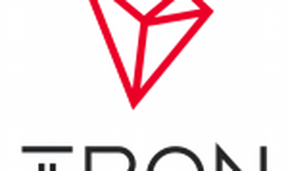

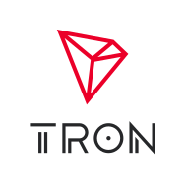

Explore

[**Tron** is a **blockchain-based decentralized digital platform** that facilitates cost-effective sharing of digital content and hosts its own cryptocurrency, **Tronix (TRX)**](https://www.investopedia.com/tech/what-tron-trx/) [1](https://www.investopedia.com/tech/what-tron-trx/). Here are **five free resources** where you can learn more about Tron:

1. [**Investopedia**](https://www.investopedia.com/tech/what-tron-trx/): Provides an in-depth explanation of Tron’s platform and its features.
2. [**The Balance**](https://www.thebalancemoney.com/tron-trx-explained-5193389): Offers insights into Tron as a cryptocurrency and its smart contract capabilities.
3. [**CoinGecko**](https://www.coingecko.com/learn/beginners-guide-to-tron): A beginner’s guide to Tron, covering its mission and how it bridges the gap between content creators and consumers.
4. [**TRON Developer Hub**](https://developers.tron.network/docs/getting-start): A comprehensive resource for building Web3 applications on Tron, including tutorials, tools, and examples.
5. [**TRONDAO**](https://dev.trondao.org/developers/resources/get-started/): Provides documentation, tools, and a supportive developer community for getting started with Tron.

Feel free to explore these resources to deepen your understanding of Tron! 🚀🌐